**Reflective Portfolio Unit 8:** Name:_____________________

At the conclusion of unit 8, you will create a **one page** front and back reflective study sheet

**Section #1: Vocabulary: Write a definition for each**

1. Vertex (turning point):
2. Roots:

**Section #2: Formulas/Equations/Rules (Show the process)**

|  |  |
| --- | --- |
| **Standard form of quadratic equation** | **Quadratic formula** |
| **Vertex form of quadratic equation** | **Axis of symmetry equation** |

**Section #3: Key methods and concepts**

* **4) Types of factoring (GCF, DOPS, Trinomials including with a>1.**

1.  **B)**  **C)** 

**5) Five ways to solve a quadratic equation:**

1. **Solve by factoring: $x^{2}+8x+12=0$ b. Solve by using quadratic formula: $x^{2}+8x+12=0$**
2. **Solve by completing the square: $x^{2}+8x+12=0$**

1. **Solve by using square root property**

**E .A ball is thrown into the air from the ground. It is expected to reach its maximum height and then fall down to the ground. Its height, h, in feet can be predicted by the equation,**

$h = -16t^{2} + 80t$, **where t is time in seconds. Sketch the graph.**

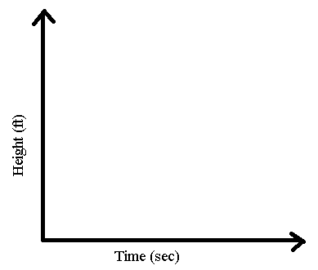A**) Algebraically determine when does the ball reach the ground?**

1. **Write a possible cube function from the given graphs:**

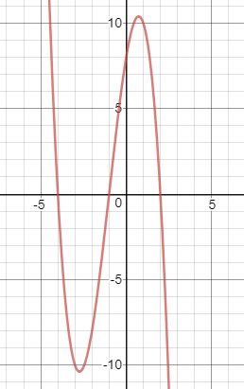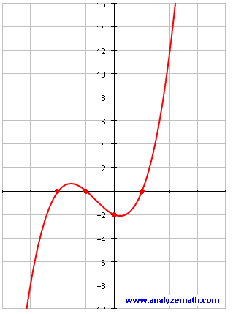

This study guide needs to be NEAT and ORGANIZED!